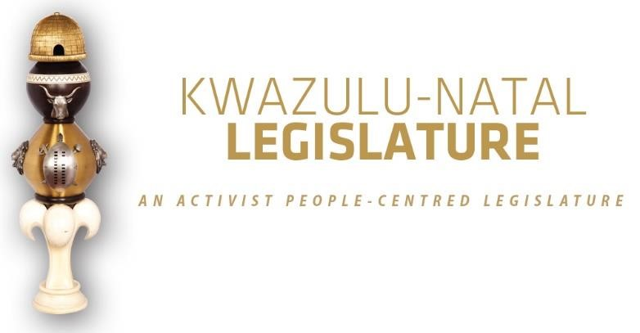

[No. 16/2026] THIRD SESSION, SEVENTH LEGISLATURE

= = = = = = = = = = =

ANNOUNCEMENTS AND TABLINGS

= = = = = = = = = = =

30 JULY 2026

HYBRID SITTING: 09H00

- PRAYER (Item 1 on the Order Paper)

Opportunity for Prayers or Silent Meditation

- OBITUARIES (Item 2 on the Order Paper)

Honourable Members, in the spirit of respect and remembrance, this House pauses to reflect on the lives of those who have recently departed. Their contributions large or small, public or private have helped build the communities we serve and cherish today.
To the families and loved ones who grieve their loss, we convey our sincere condolences. May the memory of their service bring comfort and enduring pride.

We now pay tribute to the following individuals:

  - Mr Meshack Nzuza the father (ubaba omncane) of Mr Zethembiso Nzuza Senior Manager: Committees, passed away on Saturday following a short illness;

  - Mr Leonard Siyabonga Dladla, the brother of Mr Thamsanqa Dladla, Manager in the Office of the Secretary, passed away on Sunday following a short illness;

  - Victims of gender-based violence, femicide, and hate crimes;

  - Public servants and traditional leaders of our province and the country at large;

  - Flood victims;

  - Artists and veterans of the entertainment industry; and

  - All those who have tragically lost their lives in road accidents across our province in recent weeks.

I now invite the House to observe a moment of profound silence in honour of all those who have passed on.”

- ANNOUNCEMENTS BY THE SPEAKER (Item 3 on the Order Paper)

  - APOLOGIES:

    - Honourable Ms CM Shinga, MEC for Social development has requested permission to be excused from the remainder of today’s sitting due to pressing official commitments; and

    - Honourable Mr MW Twala and honourable Ms T Nkosi have an organizational commitment.

  - CHANGE OF MEMBER’S OFFICIAL NAMES

The House is hereby informed that Honourable Ms Sizophila Mpilo-Iyaqhubeka Magnificent Mkhize has officially changed her names, as reflected in her updated Identity Document. Her official name is now Honourable Ms Sizophila Magnificent Mkhize, and she should henceforth be addressed and recorded as such in all parliamentary proceedings and official documentation.

  - CIVIC VOTER EDUCATION PROGRAMME – UGU DISTRICT MUNICIPALITY 31 JULY 2026

Honourable Members are reminded, as per the weekly Schedule circulated to Members, that the KwaZulu-Natal Legislature will conduct a Civic Voter Education Programme in the Ugu District Municipality on Friday, 31 July 2026.
The programme will be hosted at the following venues:

- Team A: Dumayo Hall, Ward 1, Mdoni Local Municipality; and
- Team B: KwaXolo Traditional Court Hall, Ward 8, Ray Nkonyeni Local Municipality.

The GPS coordinates for both venues will be shared together with the deployment list.

Members participating in the programme are advised that weather conditions in the Ray Nkonyeni area are expected to be partly cloudy, with a 30% chance of rain and temperatures ranging between 11°C and 19°C, according to forecasts from the South African Weather Service.

Honourable Members are therefore encouraged to dress warmly and wear comfortable footwear to ensure their comfort while engaging with communities.

Your participation in this important programme, which seeks to strengthen civic awareness and promote voter education, is greatly appreciated.

3.4 2026 UMKHOSI WESIVIVANE

I wish to inform the House that His Majesty King Misuzulu kaZwelithini has extended a cordial invitation to all Members of the KwaZulu-Natal Legislature to attend the 2026 Umkhosi WeSivivane, which will take place on Saturday, 1 August 2026, at 09h00, at the eMashobeni Royal Palace in the Pongola Local Municipality.

Honourable Members are further advised that this event coincides with the Open Voter Registration Weekend. Members are therefore encouraged to exercise their discretion regarding attendance, taking into account their respective commitments during this period.

  - 2026 WOMEN’S PARLIAMENT

Honourable members, please note that the 2026 Women’s Parliament will take place on 6 and 7 August 2026 at Peace Initiative Hall, Johannes Phumani Phungula Municipality, Harry Gwala District. Proceedings will start at 09h00.

- ANNOUNCEMENTS OR REPORTS BY THE PREMIER (Item 4
on the Order Paper)

Opportunity for the Premier to make Announcements.

5. TABLING OF REPORTS OR PAPERS (Item 5 on the Order Paper)

5.1 Portfolio Committee on Premier, Community Safety and Liaison:

Report of the Premier, Community Safety and Liaison Portfolio Committee in terms of Standing Rule 154 on the Recommendation of a Renewal of the Term of Office for the KwaZulu-Natal Public Service Commissioner.

5.2 Standing Committee on Public Accounts:

Report of the Standing Committee on Public Accounts on the KwaZulu-Natal Second Unauthorised Expenditure Authorisation Bill, 2026.

5.3 Portfolio Committee on Health:

A Concept Document for the 2026/27 Health Institutions Functionality Monitoring Program (HIFMP), Proposed Topic: A Comparative Study Assessing and Analyzing KwaZulu-Natal Emergency Medical Services (KZN EMS) Performance for the 2025/26–2026/27 Financial Years.

5.4 Committee on Scrutiny of Subordinate Legislation:

5.4.1 Scrutiny of Subordinate Legislation Standing Committee Report on the KwaZulu-Natal Gaming and Betting Amendment Regulations and a Repeal and Replacement of Schedule 2 of the KZN Gaming and Betting Act, No.3 of 2010 from the Department of Economic Development, Tourism and Environmental Affairs in terms of Rule 154(1) of the Standing Rules.

5.4.1.1 Analysis of comments on input to KZN Gaming and Betting draft Amendment Regulations (Attachment to the Report in 5.3.1 above);

5.4.2 KwaZulu-Natal Repeal and Replacement of Schedule 2 to the KwaZulu-Natal Gaming and Betting Act, 2010 (No.8 Of 2010) [as amended and adopted by the Standing Committee on Scrutiny of Subordinate Legislation on the 29th of July 2026];

5.4.3 KwaZulu-Natal Gaming and Betting Amendment Regulations, 2025 [as amended and adopted by the Standing Committee on Subordinate Legislation on the 29th of July 2026];

5.4.4 KwaZulu-Natal Repeal and Replacement of Schedule 2 to the KwaZulu-Natal Gaming and Betting Act, 2010 (No.8 of 2010); and

5.4.5 KwaZulu-Natal Gaming and Betting Amendment Regulations, 2025.

5.5 Quality of Life Standing Committee:

5.5.1 2025 Senior Citizens Parliament Report; and

5.5.2 2025 Disability Parliament Report.

6. FORMAL MOTIONS OR NOTICES BY THE CHIEF WHIP (Item
6 on the Order Paper)

Opportunity for the Chief Whip to present motions or notices.

7. Members’ Statements [SR 114] (Item 7 on the Order Paper).

8. ORDERS OF THE DAY (Item 8 on the Order Paper)

8.1 Election of the Chairperson of Committees.

8.2 Debate on SR 113(1) Report on Vote 1 as delivered by the Premier on 23 April 2026;

8.3 Debate on SR 113(1) Report on Vote 3 as delivered by the MEC for Agriculture and Rural Development on 23 April 2026;
8.4 Debate on the SR 113(1) Report on Vote 4 as delivered by the MEC for Economic Development, Tourism and Environmental Affairs on 23 April 2026;

8.5 Debate on the Section SR 113 (1) Report on Vote 5 as delivered by the MEC for Education on 23 April 2026; and

8.6 Debate on the Performance Report of the Portfolio Committee on Public Works and Infrastructure against its Annual Oversight Plan for the Financial Year 2025/2026 [SR154(c)].

∞ ∞∞ ∞

