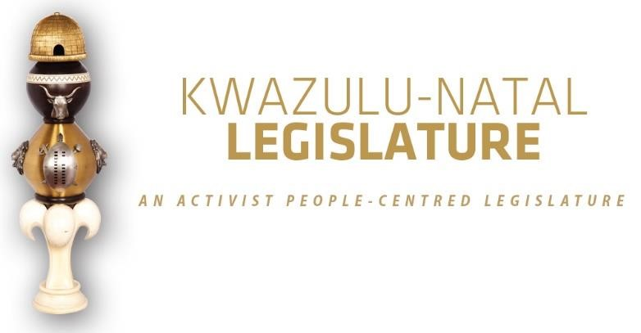

[No. 15/2026] THIRD SESSION, SEVENTH LEGISLATURE

= = = = = = = = = = =

ANNOUNCEMENTS AND TABLINGS

= = = = = = = = = = =

21 JULY 2026

HYBRID SITTING: 15H30

- PRAYER (Item 1 on the Order Paper)

Opportunity for Prayers or Silent Meditation

- OBITUARIES (Item 2 on the Order Paper)

Honourable Members, in the spirit of respect and remembrance, this House pauses to reflect on the lives of those who have recently departed. Their contributions large or small, public or private have helped build the communities we serve and cherish today.
To the families and loved ones who grieve their loss, we convey our sincere condolences. May the memory of their service bring comfort and enduring pride.

We now pay tribute to the following individuals:

2.1 The legendary South African actor Seputla Sebogodi [famously known as Kenneth Mashaba], whose remarkable career helped shape generations of South African storytelling and entertainment. A gifted performer of immense talent and distinction, he leaves behind a legacy that will continue to inspire artists and audiences for years to come.

Seputla Sebogodi became a household name through a succession of memorable television performances that showcased his extraordinary versatility and commanding screen presence. His work in acclaimed productions such as Generations, Suburban Bliss, Bophelo ke Semphego, Redemption, and most recently Scandal, endeared him to millions of viewers across the country and cemented his place among South Africa’s most respected actors.

Beyond his success on television, Sebogodi was a celebrated theatre practitioner whose contribution to the stage was equally profound. His distinguished theatre career featured acclaimed productions including Big Dada, Waiting for Godot, The Rivonia Trial, Once a Pirate, and Mooi Street Moves, among many others. Through these performances, he demonstrated an unwavering commitment to the craft of storytelling and the development of South African theatre.

2.2 Victims of gender-based violence, femicide, and hate crimes;

2.3 Public servants and traditional leaders of our province and the country at large;

2.4 Flood victims;

2.5 Artists and veterans of the entertainment industry; and

2.6 All those who have tragically lost their lives in road accidents across our province in recent weeks.

I now invite the House to observe a moment of profound silence in honour of all those who have passed on.”

- ANNOUNCEMENTS BY THE SPEAKER (Item 3 on the Order Paper)

  - APOLOGIES:

3.1.1 No apologies have been submitted to the Office of the Speaker for consideration.

3.2 SWEARING-IN OF A NEW MEMBER

Honourable Members, following the untimely passing of Honourable Dr N.N.G. Mahlaba, a vacancy arose in the representation of the African National Congress in this esteemed House.

In accordance with the applicable legislative and constitutional provisions, the vacancy has been duly filled. I therefore wish to inform the House that Honourable Ms Zinhle Lindeka Immaculate Cele was officially sworn in as a Member of the KwaZulu-Natal Legislature on Thursday, 16 July 2026, in the Speaker’s Office.

On behalf of the KwaZulu-Natal Legislature, I extend a warm and heartfelt welcome to Honourable Cele. We congratulate her on her appointment and wish her every success as she assumes her responsibilities in service of the people of KwaZulu-Natal.

We are confident that she will discharge her duties with dedication, integrity, and a steadfast commitment to advancing the interests and aspirations of the citizens of our province.

We look forward to her valuable contribution to the deliberations and work of this House.

Once again, Honourable Cele, welcome to the KwaZulu-Natal Legislature.

3.3 NOTIFICATION OF SURNAME CHANGE:

The Office of the Speaker has received formal notification, together with the requisite supporting documentation, from Honourable Mr CT Mohaeka regarding the change of his surname from Khanyi to Mohaeka.

Honourable Members are kindly requested to note that, with effect from today, Honourable CT Khanyi is henceforth known as Honourable Mr CT Mohaeka. The updating of his personal details across all relevant systems within the Legislature will be processed in due course.

3.4 INVITATION: 2026 JOINT YOUNG WOMEN’S AND LGBTQIA+ SYMPOSIUM:

Honourable Members are notified and invited to attend the 2026 joint Young Women's and LGBTQIA+ Symposium which will be held on Thursday, 23 July 2026 starting at 09H00 at Truro Hall in the Northdale area, Pietermaritzburg under Msunduzi Municipality.
3.5 VOTING ANNOUNCEMENT ON PARTY VOTING DURING THE SITTING

Honourable Members are reminded that this sitting will be conducted in terms of our Standing Rules.

Party voting

Rule 288(4) of the Rules states that –

The presiding officer or chairperson must, before or at the start of the discussion on the matter, expressly inform members if a party vote will be taken.

In line with the above, I can confirm that voting will take place on the –

- Voting on the KwaZulu-Natal Appropriation Bill, 2026.

Bear in mind that a party vote is a collective vote on behalf of all the Members of a party present at a virtual sitting, up to the total membership of that party in the sitting.

I will, however, allow an opportunity for any individual Member to vote differently from his/her party, or to abstain, if any Member wishes to do so.

We will now proceed with the rest of the items on the
Order Paper.

- ANNOUNCEMENTS OR REPORTS BY THE PREMIER (Item 4
on the Order Paper)

Opportunity for the Premier to make Announcements.

5. TABLING OF REPORTS OR PAPERS (Item 5 on the Order Paper)

5.1 KwaZulu-Natal Legislature:

5.1.1 KwaZulu-Natal Legislature Annual Performance
Plan 2026/2027.

6. FORMAL MOTIONS OR NOTICES BY THE CHIEF WHIP (Item
6 on the Order Paper)

Opportunity for the Chief Whip to present motions or notices.

7. ORDER OF THE DAY (Item 8 on the Order Paper)

7.1 Voting on the KwaZulu-Natal Appropriation Bill, 2026.

∞ ∞∞ ∞

