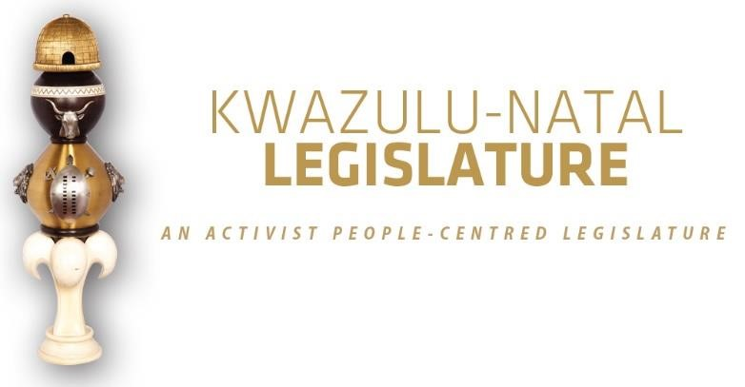

[No. 05/2026] THIRD SESSION, SEVENTH LEGISLATURE

= = = = = = = = = = =

ANNOUNCEMENTS AND TABLINGS

= = = = = = = = = = =

19 MARCH 2026

HYBRID SITTING: 09H00

- PRAYER (Item 1 on the Order Paper)

Opportunity for Prayers or Silent Meditation

- OBITUARIES (Item 2 on the Order Paper)

Honourable Members, before we proceed with today’s agenda, the House pauses to reflect on and pay homage to several remarkable individuals who have recently passed on. Their absence is deeply felt, yet the influence of their work, their leadership, and their dedication continues to be woven into the fabric of our communities and our province.
As we remember them today, we do so with profound respect and appreciation for the roles they fulfilled and the contributions they made. To their families, friends, and all who walked alongside them, this House extends heartfelt sympathies. May they find solace in knowing that the legacy of their loved ones endures in the lives they touched and the progress they inspired.

Honourable Members, we now honour the following individuals:

  - Inkosi Phathisizwe Philbert Luthuli, the esteemed head of the Umnini Trust Traditional Authority in Umgababa a steadfast pillar of wisdom, unity and progress within his community. His unwavering guidance and his deep involvement in local development initiatives have left an indelible mark on the lives of the people he served with honour and humility;

  - Ms Nompumelelo Magagula, a veteran Entertainment Reporter and one of the most respected journalists in South Africa’s media fraternity. Ms Magagula was widely admired for her exceptional dedication to storytelling, her incisive reporting on social issues, and her unwavering commitment to mentoring young journalists entering the newsroom.

She began her journey at City Press in 2018 as an intern. Through hard work, talent, and an unshakeable commitment to journalistic integrity, she rose steadily through the ranks to become a Senior Entertainment Reporter. Over the years, her work not only informed the public but also helped shape national conversations within the entertainment and cultural sectors.

Colleagues and industry peers have described Ms Magagula as a passionate, principled, and generous professional, someone whose voice and presence enriched the media landscape. Her passing leaves a profound void in the world of journalism;

  - Victims of gender-based violence, femicide, and hate crimes;

  - Flood victims;

  - Public servants and traditional leaders of our province and the country at large;

  - Artists and veterans of the entertainment industry; and

  - All those who have tragically lost their lives in road accidents across our province in recent weeks.

I now invite the House to observe a moment of profound silence in honour of all those who have passed on.”

- ANNOUNCEMENTS BY THE SPEAKER (Item 3 on the Order Paper)

3.1 VOTING ANNOUNCEMENT ON PARTY VOTING DURING THE SITTING

Honourable Members are reminded that this sitting will be conducted in terms of our Standing Rules.

Party voting

Rule 288(4) of the Rules states that –

The presiding officer or chairperson must, before or at the start of the discussion on the matter, expressly inform members if a party vote will be taken.

In line with the above, I can confirm that voting will take place on the –

- KwaZulu-Natal Second Adjustments Appropriation Bill, 2026

Bear in mind that a party vote is a collective vote on behalf of all the Members of a party present at a virtual sitting, up to the total membership of that party in the sitting.

I will, however, allow an opportunity for any individual Member to vote differently from his/her party, or to abstain, if any Member wishes to do so.

We will now proceed with the rest of the items on the Order Paper.

  - APPOINTMENT OF MEMBERS TO COMMITTEES

In terms of Standing Rules 143(4), names of members appointed to Committees must be published in the Announcements, Tablings and Committee Reports (ATC) without delay.

The changes affect the MK Party and membership has been changed on 11 March 2026 in the following Committees:

- Transport; and
- Scrutiny of Subordinate Legislation.

  - NATIONAL WATER WEEK 2026, STRENGTHENING OUR COMMITMENT TO SUSTAINABLE WATER MANAGEMENT:

Honourable Members, as we observe National Water Week from 16 to 20 March 2026, we are reminded that water is one of our most precious and limited resources essential for life, economic development, and the preservation of our environment.

This year’s theme, “Every Drop Counts,” calls on each of us to act responsibly in conserving water, protecting our rivers and ecosystems, and using this vital resource wisely. These efforts are especially critical as we confront increasing pressures brought about by climate change, population growth, pollution, and aging water infrastructure.

The KwaZulu-Natal Legislature reaffirms its commitment to strengthening policies, improving water management systems, and raising public awareness. We further call on all sectors, government, communities, business, and civil society to work together to ensure “Water For All” and to secure a sustainable and resilient future for generations to come.

  - 2026 HUMAN RIGHTS DAY COMMEMORATION:

The Premier of KwaZulu-Natal, Honourable Arthur Thamsanqa Ntuli, cordially invites all Members of the Legislature to attend the Human Rights Day Commemoration.

The event will take place on Saturday, 21 March 2026 commencing at 10h00, at Riverview Sportsfield, Ward 10, in the Greater Kokstad Local Municipality, within the Harry Gwala District Municipality.

- ANNOUNCEMENTS OR REPORTS BY THE PREMIER (Item 4
on the Order Paper)

Opportunity for the Premier to make Announcements.

5. TABLING OF REPORTS OR PAPERS (Item 5 on the Order Paper)

5.1 KwaZulu-Natal Legislature:

5.1.1 Budget Performance In-Year Monitoring Report [IYM] for the month of February 2026.
5.2 Portfolio Committee on Finance:

5.2.1 Report of the Portfolio Committee on Finance on the KwaZulu-Natal Second Adjustments Appropriation Bill, 2026; and

5.2.2 Portfolio Committee on Finance Performance Report for the First, Second and Third Quarters of 2025/26 Financial Year.

5.3 Portfolio Committee on Health:

    - Report on the Functionality of Emergency Medical Services (EMS) in KwaZulu-Natal.

5.4 Portfolio Committee on Education:

5.4.1 Portfolio Committee on Education Stakeholder Engagement held on 09 December 2025 in Osizweni Hall, Amajuba District; and

5.4.2 Portfolio Committee on Education Exam Monitoring Report: 2025.

  - Portfolio Committee on Sport, Arts and Culture:

    - 2025/26 Focus Intervention Study – Assessing and
Monitoring Sports Transformation; and

5.5.2 Belgrade Fitness Centre Oversight Visit Report.

  - Portfolio Committee on Cooperative Governance and Traditional Affairs:

    - Performance targets Report as per the Portfolio Committee on Cooperative Governance and Traditional Affairs 2025/26 Annual Oversight Plan.

  - Portfolio Committee on Conservation and Environmental Affairs:

    - Performance Report for the First, Second and Third Quarters of 2025/26 Financial Year.

  - Portfolio Committee on Premier, Community Safety and Liaison:

    - Portfolio Committee on Premier, Community Safety and Liaison Performance Report 2025/26.

5.9 Public Participation and Petitions Standing Committee:

5.9.1 Public Participation and Petitions Standing Committee
Performance Report 2025/26.

5.10 Department of Cooperative Governance and Traditional Affairs:

5.10.1 Minutes of the Oversight Committee meetings on the Annual Report for 24/25.

6. FORMAL MOTIONS OR NOTICES BY THE CHIEF WHIP (Item
6 on the Order Paper)

Opportunity for the Chief Whip to present motions or notices.
7. Notices of Bills and Motions (Item 7 on the Order paper)

8. ORDERS OF THE DAY (Item 8 on the Order Paper)

8.1 Debate and Voting on the KwaZulu-Natal Second Adjustments Appropriation Bill, 2026;

8.2 Debate on the 2026 Commonwealth Day;

8.3 Debate on the 2025 Health Functionality Monitoring Programme;

8.4 Report by the Chairperson of the Portfolio Committee on Premier, Community Safety and Liaison on the achievement of targets in terms of annual performance plans of the committee for the financial year 2025/2026 [SR154(c)];

8.5 Report by the Chairperson of the Portfolio Committee on Cooperative Governance and Traditional Affairs on the achievement of targets in terms of annual performance plans of the committee for the financial year 2025/2026 [SR154(c)];

8.6 Report by the Chairperson of the Portfolio Committee on Finance on the achievement of targets in terms of annual performance plans of the committee for the financial year 2025/2026 [SR154(c)]; and

8.7 Report by the Chairperson of the Standing Committee on Public Participation and Petitions on the achievement of targets in terms of annual performance plans of the committee for the financial year 2025/2026 [SR154(c)].

∞ ∞∞ ∞

