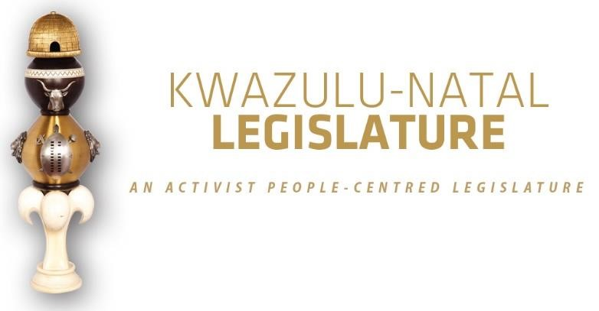

[No. 04/2026] THIRD SESSION, SEVENTH LEGISLATURE

= = = = = = = = = = =

ANNOUNCEMENTS AND TABLINGS

= = = = = = = = = = =

10 MARCH 2026

HYBRID SITTING: 09H00

- PRAYER (Item 1 on the Order Paper)

Opportunity for Prayers or Silent Meditation

- OBITUARIES (Item 2 on the Order Paper)

Before we proceed with the business of the House, let us pause to recognise and pay tribute to those distinguished individuals who have departed from our midst. Though their earthly journeys have come to an end, the impact of their lives, their service, and their contributions to our society continue to resonate within our communities and across our province.
May we honour their memories with dignity and gratitude, acknowledging the roles they played and the difference they made. To the families, friends, and colleagues they leave behind, we extend our deepest condolences and wish them strength and comfort in the knowledge that their loved ones’ legacies will not be forgotten.

Honourable Members, let us now remember the following individuals:

  - Mr Mosiuoa Gerard Patrick "Terror" Lekota an anti-Apartheid revolutionary for the African National Congress (ANC). As a member of the South African Students’ Organisation and organiser for the organisation, he was prosecuted by the apartheid regime and imprisoned on Robben Island in 1974 where he spent eight years alongside struggle leadership including Nelson Mandela.

Upon his release in 1982, he returned to his life of activism and became a leading figure in the United Democratic Front.
The UDF was a non-racial, mass movement of more than 400 grassroots organisations that was established in 1983 to oppose the National Party government’s creation of the Tricameral Parliament, which purported to be racially inclusive.
Mr Lekota’s UDF involvement led to his conviction in 1988 in the four-year Delmas Treason Trial for treason, subversion and murder, as the state tried to link non-violent resistance by the UDF to violent uprisings in the Vaal.
While he was sentenced to 12 years’ imprisonment, his conviction and those of other trialists were overturned in 1989.
Mr Lekota was a long-serving member and National Chairperson of the African National Congress, who in the democratic era became the first Premier of the Free State from 1994 to 1996, the inaugural Chairperson of the National Council of Provinces from 1997 to 1999, and Minister of Defence in 1999, a position he held until 2008.
This was also the year in which he became the Founding President of the Congress of the People;
  - Mr Soli Philander a South African comedian, actor and storyteller. He was known for his comedy, storytelling and stage work, with a career that spanned television, theatre, radio and film;

  - Mr Ian von Memerty the South Africana entertainer who was a judge on SA's Got Talent from 2009 to 2012 on e.tv and hosted Strictly Come Dancing SA on SABC3 committed suicide after he said in February that he plans to end his life because of financial struggles that he called a "terror" and issues with ageing;

  - Victims of gender-based violence, femicide, and hate crimes;

  - Flood victims;

  - Public servants and traditional leaders of our province and the country at large;

  - Artists and veterans of the entertainment industry; and

  - All those who have tragically lost their lives in road accidents across our province in recent weeks.

I now invite the House to observe a moment of profound silence in honour of all those who have passed on.”

- ANNOUNCEMENTS BY THE SPEAKER (Item 3 on the Order Paper)

  - APOLOGY:

    - Honourable Rev TD Buthelezi, MEC for Cooperative governance and Traditional Affairs has prior departmental engagements.

  - KWAZULU-NATAL LEGISLATURE COMMEMORATES COMMONWEALTH DAY

On Monday, 9 March 2026, the KwaZulu-Natal Legislature joined the 56 member states of the Commonwealth of Nations in observing Commonwealth Day, which is celebrated annually on the second Monday of March.

The theme for this year's commemoration is: "Unlocking Opportunities Together for a Prosperous Commonwealth."

This occasion provides an opportunity for member countries to reflect on collective progress and strengthen cooperation for mutual benefit. By participating in this global observance, the KwaZulu-Natal Legislature reaffirms its commitment to the values of democracy, cooperation, development, and inclusive prosperity that the Commonwealth represents.

As an institution dedicated to upholding democratic principles and fostering public participation, the KwaZulu-Natal Legislature is well-positioned to mark this day through initiatives that promote civic awareness, youth engagement, and international solidarity.

In continued observance of this important day, the Legislature has displayed the Commonwealth Parliamentary Association (CPA) flags and decorated the Chamber foyer with photographs and publications highlighting the Commonwealth. Additionally, the Commonwealth Anthem was played on the KZN Legislature TV screens prior to the commencement of the Budget Sitting.

  - BRIEFING TO ALL MEMBERS BY THE PROVINCIAL TREASURY

Honourable Members, you are kindly requested to remain seated immediately after the adjournment of the House. The Provincial Treasury will be providing a briefing, and your presence is required.

  - CHAIRPERSONS’ TRAINING ON THE DASHBOARD

Honourable Members, immediately after the adjournment of the Provincial Treasury briefing, all Chairpersons are further requested to remain behind for training on the Dashboard, to be conducted by the Provincial Treasury.

- ANNOUNCEMENTS OR REPORTS BY THE PREMIER (Item 4
on the Order Paper)

Opportunity for the Premier to make Announcements.

5. TABLING OF REPORTS OR PAPERS (Item 5 on the Order Paper)

5.1 Portfolio Committee on Agriculture and Rural Development:

5.1.1 Agriculture and Rural Development Portfolio Committee Oversight Visit in uMgungundlovu District.

5.2 Commonwealth Parliamentary Association:

5.2.1 Report of the 54th Commonwealth Parliamentary Association, CPA Africa Region 10-16th August 2025 - Banjul, The Gambia;

5.2.2 Report of the 68th Commonwealth Parliamentary Association Conference held under the theme ‘The Commonwealth – a Global Partner’ 5 to 12 October 2025 - Bridgetown, Barbados; and

5.2.3 Report on the 2026 Commonwealth Parliamentary Association commemoration day.

5.3 Department of Cooperative Governance and Traditional Affairs:

5.3.1 The Big Five Hlabisa Local Municipality Draft Annual Report 2024/2025; and

5.3.2 Progress Report on the Implementation of Section 47 Report 2023/2024 Remedial Actions; and

5.3.3 Oversight Report on the King Cetshwayo District Municipality 2024/25 Annual Report.

6. FORMAL MOTIONS OR NOTICES BY THE CHIEF WHIP (Item
6 on the Order Paper)

Opportunity for the Chief Whip to present motions or notices.

7. ORDERS OF THE DAY (Item 7 on the Order Paper)

  - Tabling of the KwaZulu-Natal Appropriation Bill, 2026 by the MEC for Finance; and

  - Tabling of the KwaZulu-Natal Second Adjustments Appropriation Bill, 2026 by the MEC for Finance.

