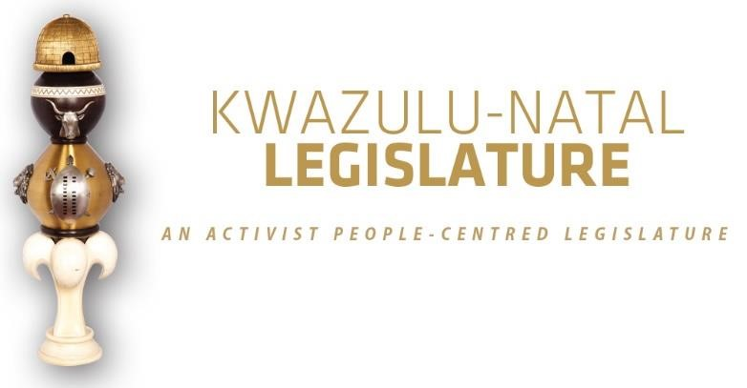

[No. 01/2026] SECOND SESSION, SEVENTH LEGISLATURE

= = = = = = = = = = =

ANNOUNCEMENTS AND TABLINGS

= = = = = = = = = = =

15 JANUARY 2026

VIRTUAL SPECIAL SITTING: 09H00

1. PRAYER (Item 1 on the Order Paper)

Opportunity for Prayers or Silent Meditation

2. OBITUARIES (Item 2 on the Order Paper)

Honourable Members, before we proceed with the business of the day, we pause to pay tribute to those who have departed.

We celebrate their lives, acknowledge their contributions, and mourn their loss. In doing so, we stand united with all families and communities who grieve during this time.

Today, we honour the memory of individuals from various walks of life, including:

- Ms Cheryl Sisoka, a devoted and disciplined servant of the African National Congress who rose steadily through the ranks of the organisation. She served the ANC with distinction at both zonal and regional levels, earning the trust and respect of many. Her commitment and leadership led to her appointment as Regional Coordinator of the ANC in eThekwini, a responsibility she carried with honour, humility, and an unwavering dedication to organisational unity.

At the time of her passing, Comrade Cheryl was serving as a Councillor in the eThekwini Metropolitan Municipality, where she held the vital position of Whip of the Community Services Committee. In this role, she executed her duties with diligence, professionalism, and a deep sense of accountability to the people she served. Her passion for community upliftment and her tireless work ethic remain an inspiration to all who worked alongside her.

Her passing leaves a profound void in the movement, the municipality, and the communities she so faithfully served;

- Ms Thandiwe Mpanza was a dedicated activist, respected veteran, and a pillar of strength within the liberation movement. A lifelong advocate for justice and community empowerment, she embodied the values of discipline, humility, and service.

She was the beloved wife of the late ANC stalwart, Comrade General Gizenga Mpanza, with whom she shared a legacy of struggle, commitment, and service to the people of South Africa. Throughout her life, Ms Mpanza remained deeply rooted in the advancement of her community and the broader ideals of the ANC, offering guidance, wisdom, and steadfast leadership to generations of activists.

Her passing marks the loss of a courageous woman whose life was defined by sacrifice, compassion, and unwavering dedication to the movement and her community;

- Victims of gender-based violence, femicide, and hate crimes;

- Flood victims;

- Public servants and traditional leaders of our province and the country at large;

- Artists and veterans of the entertainment industry; and

- All those who have tragically lost their lives in road accidents across our province in recent weeks.

Let us now observe a moment of silence in honour of all those who have gone ahead of us.

3. ANNOUNCEMENTS BY THE SPEAKER (Item 3 on the Order Paper)

3.1 VOTING ANNOUNCEMENT ON PARTY VOTING DURING THE SITTING

Honourable Members are reminded that this sitting will be conducted in terms of our Standing Rules.

Party voting

Rule 288(4) of the Rules states that –

The presiding officer or chairperson must, before or at the start of the discussion on the matter, expressly inform members if a party vote will be taken.

In line with the above, I can confirm that voting will take place on the –

- KwaZulu-Natal Adjustments Appropriation Bill, 2025;

Bear in mind that a party vote is a collective vote on behalf of all the Members of a party present at a virtual sitting, up to the total membership of that party in the sitting.

I will, however, allow an opportunity for any individual Member to vote differently from his/her party, or to abstain, if any Member wishes to do so.

We will now proceed with the rest of the items on the Order Paper.

3.2 ABSENCE OF THE MK PARTY MEMBERS AND EFF MEMBER

3.2.1 Honourable Members, I wish to inform the House that, following the disruption of the Special Sitting held on 15 December 2025, I have invoked Rule 61 of the Standing Rules of the KwaZulu-Natal Legislature.

I proceeded to suspend Members as per Rule 63. The period of suspension as per Rule 66 is for the period of five working days, effective from 12 to 16 January 2026.

Accordingly, the affected Members are prohibited from participating in any proceedings of the Legislature for the duration of their suspension.
The Whips, Party leaders and the affected Members were notified of the suspension.

4. ANNOUNCEMENTS OR REPORTS BY THE PREMIER (Item 4 on the Order Paper)

Opportunity for the Premier to make Announcements.

5. TABLING OF REPORTS OR PAPERS (Item 5 on the Order
Paper)

5.1 Standing Committee on Oversight:

5.1.1 Report of the Standing Committee on Oversight on the consideration of the 2025/2026 Mid-Year Budget Adjustments and 2026/27 Budget allocation for the Legislature.

5.2 Portfolio Committee on Finance:

5.2.1 Report of the Portfolio Committee on Finance on the KwaZulu-Natal Adjustments Appropriation Bill, 2025.

6. FORMAL MOTIONS OR NOTICES BY THE CHIEF WHIP
(Item 6 on the Order Paper)

Opportunity for the Chief Whip to present motions or notices.

7. ORDER OF THE DAY (Item 8 on the Order Paper)

7.1 Debate and Voting on the KwaZulu-Natal Adjustments Appropriation Bill, 2025.

© ©© ©

