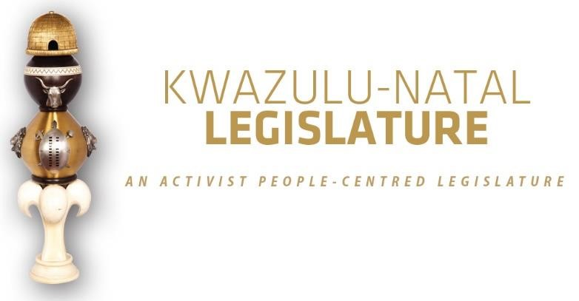

[No. 16/2025] SECOND SESSION, SEVENTH LEGISLATURE

= = = = = = = = = = =

ANNOUNCEMENTS AND TABLINGS

= = = = = = = = = = =

23 OCTOBER 2025

HYBRID SITTING: 09H00

1. PRAYER (Item 1 on the Order Paper)

Opportunity for Prayers or Silent Meditation

2. OBITUARIES (Item 2 on the Order Paper)

Honourable Members, let us take a moment to pause and remember those who have departed from us in recent times.

We honour their lives, their contributions to our communities, and the footprints they leave behind. May their memories be a blessing to those who knew and loved them.

We recognise and honour the following departed individuals:

2.1 Prince and Inkosi Alpheus Veleshowe Zulu kaZithume kaTetemane kamaGwendu kaMpande of Gagwini in Umlalazi;

2.2 All artists and veterans in the entertainment industry;

2.3 All victims of gender-based violence, femicide and hate crimes;

2.4 All public servants and traditional leaders of this province and the country at large; and

2.5 All other victims of road fatalities in our province during the recent past.

Let us now observe a moment of silence to honour all those who have gone ahead of us.

3. ANNOUNCEMENTS BY THE SPEAKER (Item 3 on the Order Paper)

3.1 RULING ON VIRTUAL SITTING AND VOTING ANNOUNCEMENT ON PARTY VOTING DURING THE SITTING

Honourable Members are reminded that this sitting will be conducted in terms of our Standing Rules.

Party voting

Rule 288(4) of the Rules states that –

The presiding officer or chairperson must, before or at the start of the discussion on the matter, expressly inform members if a party vote will be taken.

In line with the above, I can confirm that voting will take place on the –

- Debate and Voting on the Conferral of a Final
Mandate on the Public Service Amendment Bill [B13D 2023]; and

(ii) Debate and Voting on the Conferral of a Final
Mandate on the Public Administration
Management Amendment Bill [B10B-2023].

Bear in mind that a party vote is a collective vote on behalf of all the Members of a party present at a virtual sitting, up to the total membership of that party in the sitting.

I will, however, allow an opportunity for any individual Member to vote differently from his/her party, or to abstain, if any Member wishes to do so.

We will now proceed with the rest of the items on the Order Paper.

3.2 APOLOGIES

3.2.1 The Honourable Mr FA Rodgers, MEC for Finance, has requested to be excused from the sitting earlier than scheduled. He will, however, be participating in the proceedings virtually; and

3.2.2 The Honourable Mr SA Duma and the Honourable Mr SE Hlomuka will also be participating virtually. They have requested to be excused briefly in order to attend meetings with their respective Ministers and will rejoin the sitting immediately upon the conclusion of those meetings.

3.3 BIRTHDAYS

On behalf of the KwaZulu-Natal Legislature, I would like to extend our warmest wishes in advance to the following members who will be celebrating their birthdays in the coming days:

- Honourable SMB Sikhakhane on the 25th of October,
- Honourable LJ De Klerk on the 26th of October,
- Honourable MW Twala on the 27th of October, and
- Honourable CS Zuma on the 31st of October.

We wish each of you a joyful celebration and a year ahead filled with good health, fulfilment, and continued service to the people of our province.

May your special day be memorable and may the year to come bring renewed strength and inspiration.

Happy birthday in advance to all of you.

3.4 WATER OUTAGE AT THE LEGISLATURE PRECINCTS

Honourable Members, please be advised that there is currently a disruption in the water supply within the Legislature precincts. The matter has been reported to the relevant authorities and is receiving urgent attention.

In the interim, mobile sanitation facilities have been provided for the convenience of Members and staff.

We regret any inconvenience caused and appreciate your patience and understanding.

3.5 ACKNOWLEDGEMENT OF GUESTS

It is my pleasure to welcome the NFP guests who are seated in the gallery who have come to observe today’s proceedings. They are:

- Mr Joel Shinga,
- Mrs Thulisile Shinga,
- Mr Nathi Zuma,
- Mr Muziwenhlanhla Khumalo; and
- Mr Sphe Ngidi.

We trust that you will enjoy your stay with us.

4. ANNOUNCEMENTS OR REPORTS BY THE PREMIER (Item 4 on the Order Paper)

Opportunity for the Premier to make Announcements.

5. TABLING OF REPORTS OR PAPERS (Item 5 on the Order
Paper)

  - Portfolio Committee on Premier, Community Safety and Liaison:

    - Premier, Community Safety and Liaison Portfolio Committee Report on Public Service Amendment Bill [B13D-2023] in terms of Rule 261 and 262 of the Standing Rules; and
    - Premier, Community Safety and Liaison Portfolio Committee Report on Public Administration Management Amendment Bill [B10B-2023] in terms of Rule 261 and 262 of the Standing Rules.

6. FORMAL MOTIONS OR NOTICES BY THE CHIEF WHIP
(Item 6 on the Order Paper)

Opportunity for the Chief Whip to present motions or notices.

7. NOTICES OF BILLS AND MOTIONS (Item 7 on the Order Paper as per Standing Rule 106)

8. ORDERS OF THE DAY (Item 8 on the Order Paper)

8.1 Debate on the following 3rd MKP Party Motion:

On 26 November 2024, hon BC Mngadi of the MKP moved as follows:

This House notes:

The frustration faced by operating taxi owners in KwaZulu-Natal because of a failure on the part of the Department of Transport to issue operating permits on time; and

This often results in the impounding of operating taxis under the self-same department’s Operation Shanela.

This House therefore resolves:

To protect the taxi industry because as is the most accessible mode of public transport available to our people, and the most powerful black-owned business sector that sustains many families in our black communities.

8.2 Report by the MEC for Cooperative Government and Traditional Affairs on Vote 11 departmental performance against their Annual Performance Plans in line with the prescripts of the Legislature’s Standing Rule 113(1);

8.3 Debate on the following NFP Party Motion:

On 26 November 2024, hon CM Shinga of the NFP moved as follows:

This House notes:

- That township economies across KwaZulu-Natal remain underdeveloped, leaving local entrepreneurs with limited resources, opportunities, and access to markets.

- That inadequate infrastructure, such as roads, electricity, and internet connectivity, continues to hinder economic growth in these communities.

This House therefore resolves:

- To call for targeted investments in township infrastructure to stimulate business growth.

- To introduce financial incentives, such as tax breaks, for businesses operating in townships.

- To establish programs providing access to micro-loans, mentorship, and training for township entrepreneurs.

8.4 Report by the MEC for Transport and Human Settlements on Vote 12 departmental performance against their Annual
Performance Plans in line with the prescripts of the Legislature’s Standing Rule 113(1);

8.5 Debate on the following 2nd DA Party Motion:

On 21 August 2025, hon LM Meyer of the DA moved as follows:

This House notes that:

- Small rural towns need improved economic opportunities.

- The National Government owns many properties in
the province of KwaZulu-Natal that is underutilized or unutilized.

- Minister of Public Works and Infrastructure, Minister
Dean Mcpherson in July handed over properties in Nkandla to the local municipality to be used to unlock economic opportunities.

This House therefore resolves:

· To thank Minister McPherson and the national
department of Public Works for buying into the province’s vision of making sure public properties are used for the good of the public.

· To encourage the national department to
continue this program, and ensure that the
people of KwaZulu-Natal reap the benefits of publicly owned land.

8.6 Debate and Voting on the Conferral of a Final Mandate on the Public Service Amendment Bill [B13D-2023]; and

8.7 Debate and Voting on the Conferral of a Final Mandate on the Public Administration Management Amendment Bill [B10B-2023].

© ©© ©

