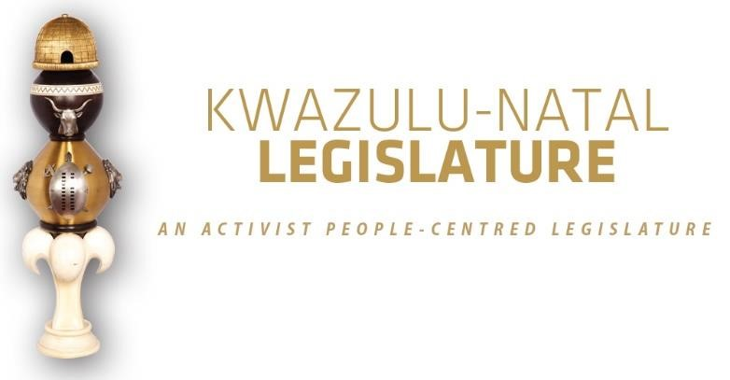

[No. 18/2025] SECOND SESSION, SEVENTH LEGISLATURE

= = = = = = = = = = =

ANNOUNCEMENTS AND TABLINGS

= = = = = = = = = = =

07 NOVEMBER 2025

HYBRID SITTING: 09H00

1. PRAYER (Item 1 on the Order Paper)

Opportunity for Prayers or Silent Meditation

2. OBITUARIES (Item 2 on the Order Paper)

Honourable Members, let us take a moment to pause and remember those who have departed from us in recent times.

We honour their lives, their contributions to our communities, and the footprints they leave behind. May their memories be a blessing to those who knew and loved them.

We recognise and honour the following departed individuals:

2.1 Our staff member and a dear colleague, Mr Caesar Christopher Ngcobo, who served with distinction as the NCOP Administration Liaison Officer in the KwaZulu-Natal Legislature.

Mr Ngcobo was a dedicated and committed public servant who devoted many years of his professional life to strengthening the work of this Legislature and enhancing the relationship between the KwaZulu-Natal Legislature and the National Council of Provinces. Through his diligence, humility, and professionalism, he made an invaluable contribution to ensuring the smooth functioning of our parliamentary processes.

He will be remembered for his unwavering dedication, quiet strength, and deep sense of duty to the institution and to the people of KwaZulu-Natal. His work ethic, collegial spirit, and warm personality earned him the respect and affection of all who had the privilege of working with him.

2.2 All artists and veterans in the entertainment industry;

2.3 All victims of gender-based violence, femicide and hate crimes;

2.4 All public servants and traditional leaders of this province and the country at large; and

2.5 All other victims of road fatalities in our province during the recent past.

Let us now observe a moment of silence to honour all those who have gone ahead of us.

3. ANNOUNCEMENTS BY THE SPEAKER (Item 3 on the Order Paper)

3.1 RULING ON VIRTUAL SITTING AND VOTING ANNOUNCEMENT ON PARTY VOTING DURING THE SITTING

Honourable Members are reminded that this sitting will be conducted in terms of our Standing Rules.

Party voting

Rule 288(4) of the Rules states that –

The presiding officer or chairperson must, before or at the start of the discussion on the matter, expressly inform members if a party vote will be taken.

In line with the above, I can confirm that party voting will take place on the –

Debate and Voting on the Report by the Chairperson of Committees on the Multi-Party Oversight Visits conducted in July 2025 in the Zululand District.

Bear in mind that a party vote is a collective vote on behalf of all the Members of a party present at a virtual sitting, up to the total membership of that party in the sitting.

I will, however, allow an opportunity for any individual Member to vote differently from his/her party, or to abstain, if any Member wishes to do so.

We will now proceed with the rest of the items on the Order Paper.

3.2 APOLOGIES

3.2.1 Honourable Mr SA Duma, MEC for Transport and Human Settlements, has a pre-scheduled departmental commitment. However, the Honourable MEC will be joining the proceedings virtually;

3.2.2 Honourable Ms CS Zuma has a family commitment; and

3.2.3 The Office of the Speaker wishes to place on record an apology received from the Economic Freedom Fighters (EFF) Caucus. The EFF Caucus has indicated that they will not be in attendance at this year’s Taking the Legislature to the People (TLtP) programme due to party commitments.

3.3 MEMBERS WHO ARE NOT WELL

- Honourable Ms IH Manchero-Barciela;
- Honourable Mr SPG Mbatha(Moyo); and
- Honourable Mr MA Dirks.

3.4 BIRTHDAYS

Honourable Members, before we proceed with today’s business, I would like to take a moment to celebrate some of our colleagues who have recently marked, or will soon be marking, their birthdays.

We extend our warmest belated birthday wishes to Honourable Ms NP Dlamini and Honourable Ms HGS Mavimbela, who both celebrated their birthdays on the 2nd of November.

We also wish a very happy birthday to Honourable HS Lidgett and Honourable T Nkosi, who celebrated their special day on the 5th of November.

And lastly, we send our best wishes in advance to Honourable Ms CQ Madlopha and Honourable Mr AT Ntuli, who will be celebrating their birthdays on the 11th of November.

On behalf of the KwaZulu-Natal Legislature, we wish you all continued happiness, good health, and success in the year ahead. May your days be filled with joy, laughter, and all the blessings life has to offer.

Happy birthday to each one of you!

3.5 NOVEMBER: SUGAR DIABETES AWARENESS MONTH

Honourable Members, I wish to take this moment to remind the House that the month of November is internationally observed as Sugar Diabetes Awareness Month. This period serves as an important platform to highlight the growing impact of diabetes on individuals, families, and communities across our province and the nation at large.

As representatives of the people of KwaZulu-Natal, it is incumbent upon us to use our positions to raise awareness and educate our constituencies about the prevention, early detection, and effective management of diabetes. Through collective advocacy and responsible lifestyles, we can contribute meaningfully towards reducing the burden of this condition in our society.
Let us, therefore, as Members of this august House, reaffirm our commitment to promoting public health and well-being among our people.

4. ANNOUNCEMENTS OR REPORTS BY THE PREMIER (Item 4 on the Order Paper)

Opportunity for the Premier to make Announcements.

5. TABLING OF REPORTS OR PAPERS (Item 5 on the Order
Paper)

  - KwaZulu-Natal Legislature:

5.1.1 Second Quarter and Mid-Year Institutional Performance Report.

  - Multiparty Women’s Caucus:

    - Multiparty Women’s Caucus 2025/26 Second Quarter Performance Report, 29 October 2025.

  - Portfolio Committee on Sport, Arts and Culture:

    - Portfolio Committee on Sport, Arts, and Culture 2025/26 First Quarter Performance Report; and

    - Portfolio Committee on Sport, Arts, and Culture 2025/26 Second Quarter Performance Report.

  - Committee of Chairpersons:

5.4.1 Quarter 2 of 2025/26 Management on Committee Resolutions.

  - Portfolio Committee on Human Settlements:

    - Oversight Report for the Portfolio Committee on Human Settlements visit to KwaDukuza Municipal Council Chamber on 10 December 2024; and

    - Report of the Portfolio Committee on Human Settlements on the oversight visit to King Cetshwayo District, Mthonjaneni Council Chamber on 11 June 2025.

6. FORMAL MOTIONS OR NOTICES BY THE CHIEF WHIP
(Item 6 on the Order Paper)

Opportunity for the Chief Whip to present motions or notices.

7. STATEMENTS BY MEMBERS (Item 7 on the Order Paper as per Standing Rule 114)

8. ORDERS OF THE DAY (Item 8 on the Order Paper)

8.1 Report by the Chairperson of Committees on the Multi-Party Oversight Visits conducted in July 2025 in the Zululand District; and

8.2 Debate and Voting on the Report by the Chairperson of Committees on the Multi-Party Oversight Visits conducted in July 2025 in the Zululand District.

© ©© ©

