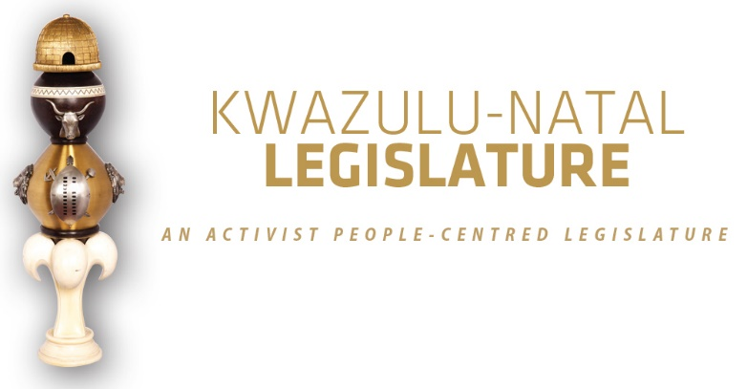

[No.17/2025] SECOND SESSION, SEVENTH LEGISLATURE

= = = = = = = = = = =

ANNOUNCEMENTS, TABLINGS AND
COMMITTEE REPORTS

= = = = = = = = = = =

TUESDAY, 04 NOVEMBER 2025

VIRTUAL SPECIAL SITTING: 08H00

1. PRAYER (Item 1 on the Order Paper)

Opportunity for Prayers or Silent Meditation.

2. ANNOUNCEMENTS BY THE SPEAKER (Item 2 on the Order
Paper)

2.1 ANNOUNCEMENT REGARDING THE REASON FOR THE VIRTUAL SPECIAL SITTING OF TODAY, TUESDAY, 04 NOVEMBER 2025

Honourable Members, thank you for availing yourselves for today’s special sitting. The Office of the Speaker was advised to call a special sitting to comply with NCOP processes and to enable the Legislature to participate in the mandates required at the NCOP. Today’s special sitting is being held to deal with the debate and voting on the-

Conferral of Final Mandate on the Independent Municipal
Demarcation Authority Bill [B14D-2022].

I trust Members will find this to be in order.

2.2 RULING ON VIRTUAL SITTING AND VOTING ANNOUNCEMENT ON PARTY VOTING DURING THE SPECIAL SITTING

Honourable Members, you are reminded that this is a special sitting, with Members having connected virtually. As always, the sitting will be conducted in terms of our Standing Rules.

Party voting

Rule 288(4) of the Rules states that –

The presiding officer or chairperson must, before or at the start of the discussion on the matter, expressly inform members if a party vote will be taken.

In line with the above, I can confirm that voting will take place on the Conferral of Final Mandate on the Independent Municipal Demarcation Authority Bill [B14D-2022].

Bear in mind that a party vote is a collective vote on behalf of all the Members of a party present at a virtual sitting, up to the total membership of that party in the sitting.

I will, however, allow an opportunity for any individual Member to vote differently from his/her party, or to abstain, if any Member wishes to do so.

We will now proceed with the rest of the items on the Order Paper.

3. ANNOUNCEMENTS OR REPORTS BY THE PREMIER (Item 3 on the Order Paper)

Opportunity for the Premier to make Announcements.

4. TABLING OF REPORTS OR PAPERS (Item 4 on the Order Paper)

4.1 Honourable Members, the Office of the Speaker wishes to report that no tablings have been received for today’s sitting.

5. FORMAL MOTIONS OR NOTICES BY THE CHIEF WHIP (Item 5 on Order Paper)

Opportunity for the Chief Whip to present motions or notices.

6. ORDER OF THE DAY (Item 6 on the Order Paper)

6.1 Debate on the Conferral of Final Mandate on the
Independent Municipal Demarcation Authority Bill [B14D-2022].

∞ ∞∞ ∞

