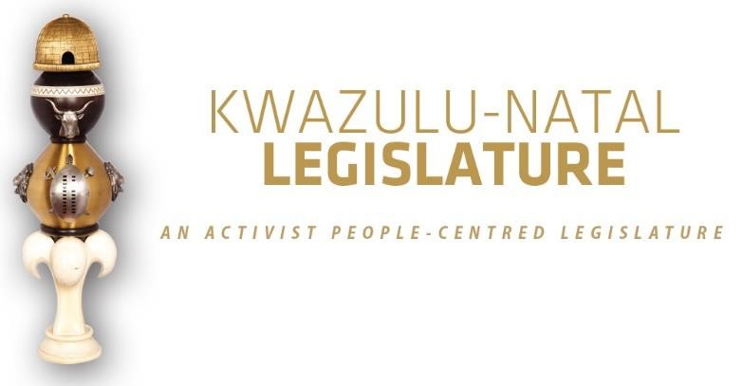

[No. 10/2025] SECOND SESSION, SEVENTH LEGISLATURE

= = = = = = = = = = =

ANNOUNCEMENTS AND TABLINGS

= = = = = = = = = = =

25 JULY 2025

VIRTUAL SITTING: 09H00

- PRAYER (Item 1 on the Order Paper)

Opportunity for Prayers or Silent Meditation

- OBITUARIES (Item 2 on the Order Paper)

Honourable Members, let us take a moment to remember in our thoughts and prayers all those souls who have departed from us in recent times. We want to mention the following persons in particular:

2.1 Theresa Solomons, Cape Town’s first black female mayor and anti-apartheid stalwart. She served as deputy mayor in the city from 1995 to 1996; and then served as mayor from 1996 to 1998.

Ms Solomons dedicated her life to the struggle for justice and equality. She was part of several movements in the Western Cape including the Black Women’s Organisation and helped to set up several civic organisations which eventually merged into one umbrella civic organisation, the Cape Areas Housing Action Committee.

She later served as South Africa’s High Commissioner to Tanzania and Canada;

  - Princess Henrietta Ntombibomvu Zulu, an esteemed member of the Zulu Royal family. Princess Henrietta’s long life was one of quiet dignity and service, a bridge between generations. She carried the hopes and traditions of our people with grace and strength. She was 102 years old and was the only remaining child of the late King Solomon kaDinuzulu;

  - Ms Pearl Sebolao, Executive Editor of the Sowetan. A renowned journalist and editor who passed away on Saturday after a short illness at the Johannesburg Surgical Hospital in Northcliff;

  - Victims of the deadly fire that engulfed the Kennedy Road Informal Settlement in the early of hours of the previous Saturday morning;

  - Five lives that were sadly lost in a fatal motor vehicle accident on the R66 at Nyezane in Gingindlovu;

  - All artists and veterans in the entertainment industry;

  - All victims of gender-based violence, femicide and hate crimes;

  - All public servants and traditional leaders of this province and the country at large; and

  - All other victims of road fatalities in our province during the recent past.

Let us now observe a moment of silence to honour all those who have gone ahead of us.

- ANNOUNCEMENTS BY THE SPEAKER (Item 3 on the Order Paper)

3.1 VOTING ANNOUNCEMENT ON PARTY VOTING
DURING THE SITTING

Honourable Members are reminded that this sitting will be conducted in terms of our Standing Rules.

Party voting

Rule 288(4) of the Rules states that –

The presiding officer or chairperson must, before or at the start of the discussion on the matter, expressly inform members if a party vote will be taken.

In line with the above, I can confirm that voting will take place on the –

- Portfolio Committee on Finance Report on the 2025/26 MTEF General Budget; and

- Report of the Standing Committee on Oversight on the Budget of Vote 2, 2025/2026 Financial Year.

Bear in mind that a party vote is a collective vote on behalf of all the Members of a party present at a virtual sitting, up to the total membership of that party in the sitting.

I will, however, allow an opportunity for any individual Member to vote differently from his/her party, or to abstain, if any Member wishes to do so.

We will now proceed with the rest of the items on the Order Paper.

- ANNOUNCEMENTS OR REPORTS BY THE PREMIER (Item 4
on the Order Paper)

Opportunity for the Premier to make Announcements.

- TABLING OF REPORTS OR PAPERS (Item 5 on the Order Paper)

  - Standing Committee on Oversight:

    - Report of the Standing Committee on Oversight on the Budget of Vote 2: KwaZulu-Natal Legislature 2025/2026 Financial Year.

  - Portfolio Committee on Finance:

    - Report of the Portfolio Committee on Finance on the 2025/26 MTEF General Budget; and

    - Report on the 2025/26 Annual Performance Plan and Budget for Vote 6: Provincial Treasury.

  - Portfolio Committee on Health:

    - Report of the Portfolio Committee on Health on the 2025/2026 Budget of the Department of Health.

  - Portfolio Committee on Education:

    - Report of the Portfolio Committee on Education on the consideration of the Budget and APP 2025/26 for the Department of Education.

  - Portfolio Committee on Cooperative Governance and Traditional Affairs:

    - Report of the Portfolio Committee on Cooperative Governance and Traditional Affairs 2025/26.

  - Portfolio Committee on Transport:

5.6.1 Report of the Portfolio Committee on Transport on the consideration of the 2025/26 Budget and Annual Performance Plan for the Department of Transport.

  - Portfolio Committee on Sport, Arts and Culture:

    - Report of the Portfolio Committee on Sport, Arts and Culture on the consideration of the 2025/26 Budget Vote 10 and Annual Performance Plan (APP) for the Department of Sport, Arts and Culture.

  - Portfolio Committee on Human Settlements:

    - Report of the Portfolio Committee on Human Settlements on the consideration of the 2025/26 Budget Vote 8 and Annual Performance Plan (APP) for the Department of Human Settlements.

5.9 Portfolio Committee on Premier, Community Safety and Liaison

    - Portfolio Committee on Premier, Community Safety and Liaison Budget Report 2025/26 Vote 1: Office of the Premier.

  - Portfolio Committee on Premier, Community Safety and Liaison:

5.10.1 Portfolio Committee on Premier, Community Safety and Liaison Budget Report 2025/26 Vote 9: Department of Community Safety and Liaison.

  - Portfolio Committee on Environmental Affairs:

5.11.1 Report of the Conservation and Environmental Affairs Portfolio Committee on the consideration of the 2025/26 Budget and Annual Performance Plan (APP) for the Environmental Affairs function of the Department of Economic Development, Tourism and Environmental Affairs.

  - Office of the Premier:

5.12.1 Office of the Premier 2025/2026 Annual Performance Plan.

  - Department of Agriculture and Rural Development:

5.13.1 Department of Agriculture and Rural Development 2025/2025 Annual Performance Plan; and

5.13.2 Department of Agriculture and Rural Development Strategic Plan 2025/2030.

  - Department of Social Development:

5.14.1 Department of Social Development 2025/2026 Annual Performance Plan; and

5.14.2 Department of Social Development Strategic Plan 2025/2030.

  - Department of Community Safety and Liaison:

5.15.1 Department of Community Safety and Liaison 2025/2026 Annual Performance Plan; and

5.15.2 Department of Community Safety and Liaison Strategic Plan 2025/2030.

  - Department of Public Works and Infrastructure:

5.16.1 Department of Public Works and Infrastructure
2025/2026 Annual Performance Plan.

- FORMAL MOTIONS OR NOTICES BY THE CHIEF WHIP (Item
6 on the Order Paper)

Opportunity for the Chief Whip to present motions or notices.

- ORDERS OF THE DAY (Item 7 on the Order Paper)

7.1 General Budget Debate and Voting on the Reports of the Portfolio Committee on Finance and the Standing Committee on Oversight; and

7.2 Committee Stage on the following Vote:

7.2.1 Vote 1: Premier.

© ©© ©

